AWS S3 LIFECYCLE MANAGER

AND

STATIC WEBSITE

Aws LifeCycle Management :

AWS provides various services and tools to manage the lifecycle of your resources, helping you optimize costs, maintain compliance, and ensure data availability.

Amazon S3 (Simple Storage Service)

S3 Lifecycle Policies: These are sets of rules that define actions to be taken on objects in an S3 bucket over time.

Transition Actions: Automatically move objects between different storage classes (e.g., from Standard to Infrequent Access or Glacier) as their access patterns change to optimize costs.

Expiration Actions: Automatically delete objects after a specified retention period, ensuring that unnecessary data does not consume storage space indefinitely.

Static Website :

Amazon S3 (Simple Storage Service) is a popular and cost-effective solution for hosting static websites. Static websites are composed of files that don't change dynamically based on user interaction or server-side processing, like HTML, CSS, JavaScript, images, and videos.

* Create a S3 bucket.

1. Choose region
2. Bucket type : General purpose bucket
3. Bucket name : myenvstorage
4. Object ownership :Acl’s enabled
5. Block all public access.
6. Encryption type : Server side encryption with amazon S3 managed keys.
7. Bucket Key : enable
8. Then create bucket.

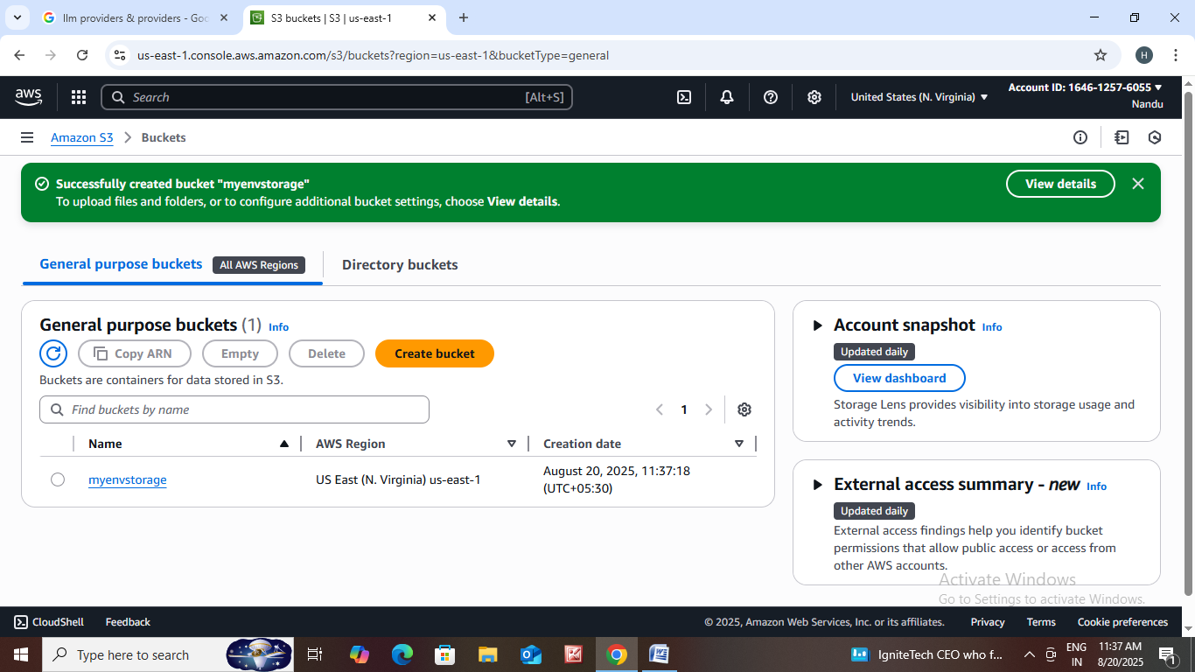

1. Then click on myenvstorage.
2. After that, click on upload add some files or folders on it.
3. Access control list : choose from predefined acl permissions.

* Predefined ACL’s : private
* Then click on upload.

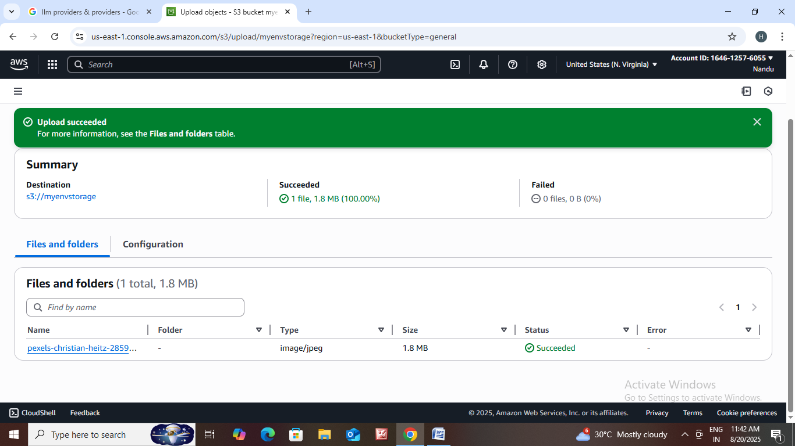

* Click on that uploaded file.

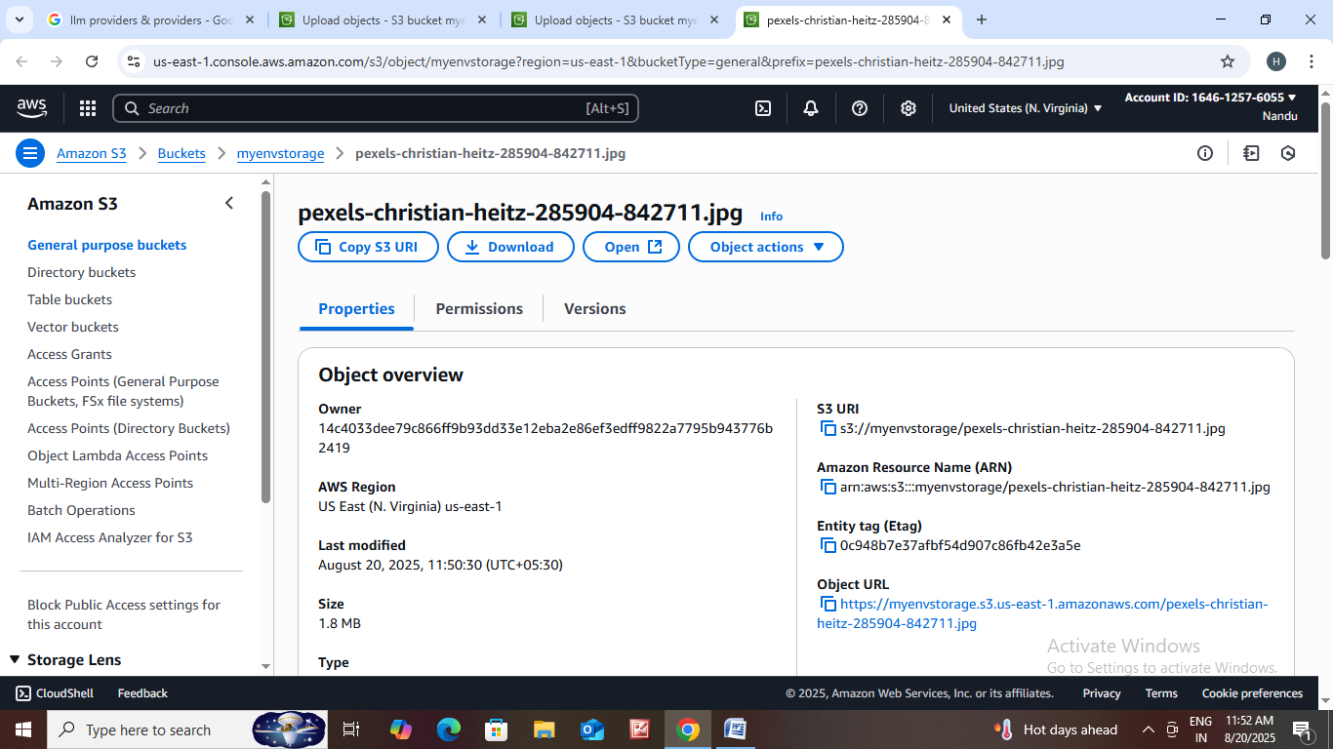

* Click on permissions.

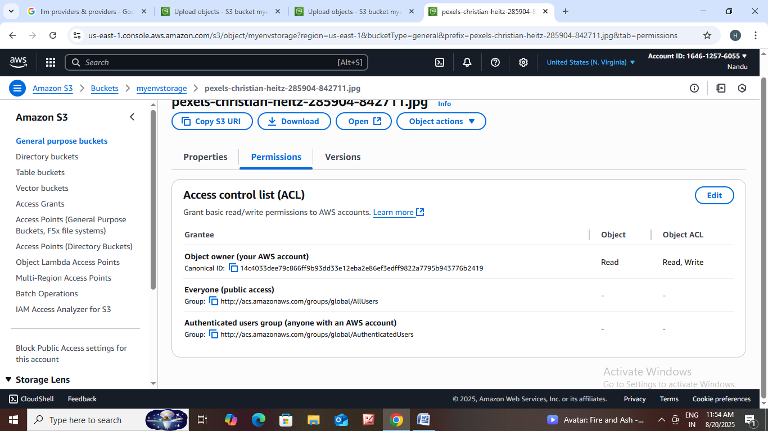

* If you want to change the permissions click on edit option.

12 . Go to myenvstorage click on Intelligent – Tiering archive configurations and then click on create configuration.

\* Configuration name : config

\* Choose a configuration scope : Limit this scope of this configuration using one or more filters.

\* Status : enable

\* Archive rule actions : Archive access tier

\* Then create it.

Enable objects stored in the Intelligent - Tiering storage class to tier-down to the Archive Access tier or the Deep Archive Access tier which are optimized for objects that will be rarely accessed for long periods of time.

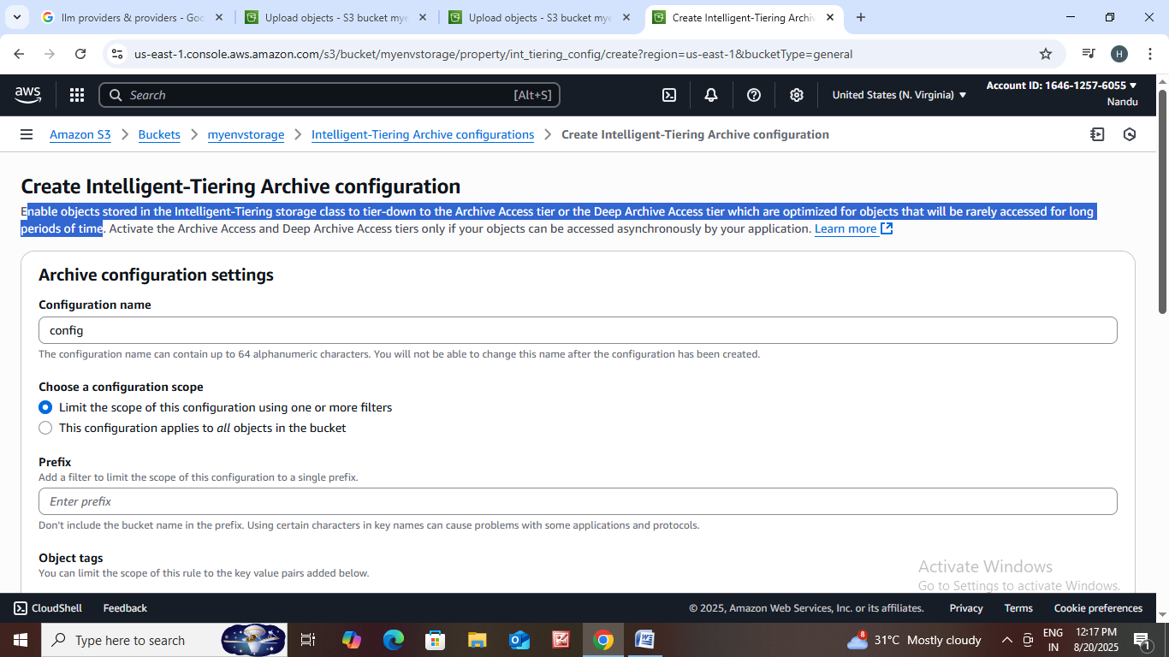

13.Let us host a static website.

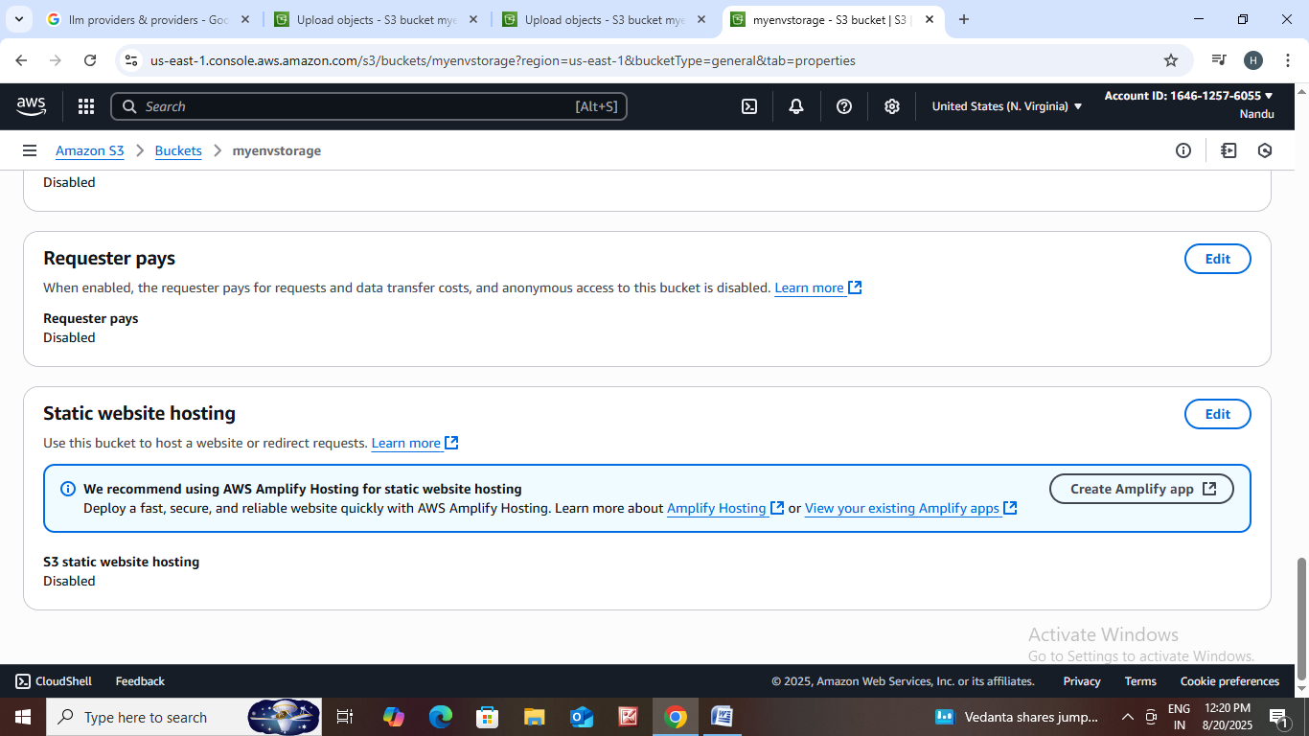

\*Click on edit.

\*Enable static website.

\*Hosting type :host a static website.

\* Enter any file name on index document.

\*Click on save changes.

\*Next go to myevnstorage click on management.

\*Then create lifecycle rule.

* Lifecycle rule name : rule101
* Rule scope : apply all objects in the bucket.
* Life Cycle rule actions : Transition current versions of objects between storage classes.
* Choose storage class transistions.
* Choose no of days after object creation.
* If you want another transistion you can add it.

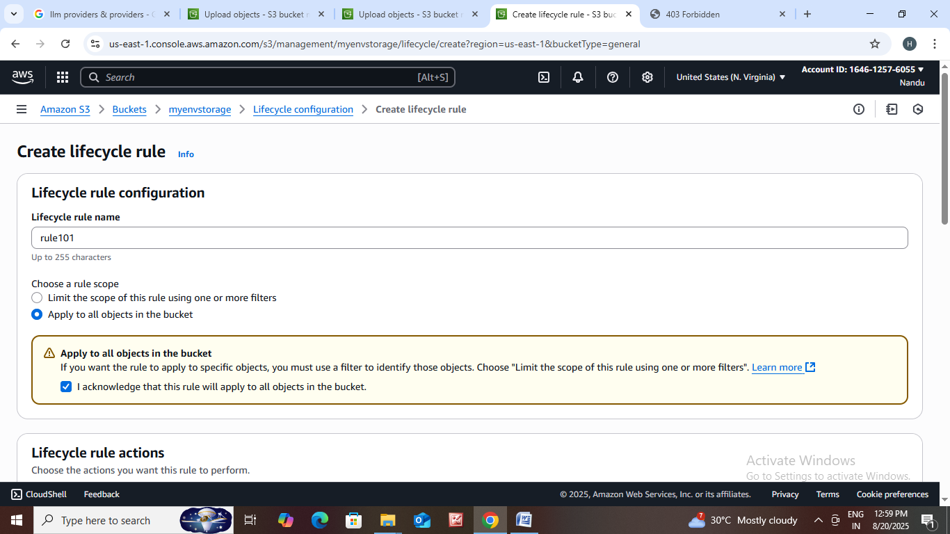

14. Let us create inventory configuration.

* Go to management then click on create inventory configuration.
* Inventory configuration name : config101
* Object version : current version only
* Destination bucket : this account
* Destination : choose your destination bucket.
* Frequency : we can select daily or weekly to generate report.
* Choose output format.
* Choose status enable or disable.
* We can add additional metafields.

15 . Let us create replication rules.

* Go to management then click on create replication rule.
* Enable bucket versioning.
* Replication rule name : rule101
* Status : enabled
* Destination : choose a bucket in this account.
* Bucket name : choose bucket name.
* IAM role : crete new role.
* After that save it.
* Next create batch operation job.
* Choose destination bucket for report.
* Then save it.

Let Us onboard a server in EC2 :

* Go to all services click on Ec2.
* In Ec2 click on instance then the page is open.
* Name : myappserver
* Choose amazon machine image.
* Choose instance type.
* Create a new key pair.
* Choose configure storage.
* After that click on launch instance.

